SNAP Program
3615 SW 13th Street, Suite 4
Gainesville, FL 32608
(352) 244-0628 ext.3822 Phone
(352) 244-0668 Fax
www.cdsfl.org
A Program of
CDS Family & Behavioral Health Services, Inc.

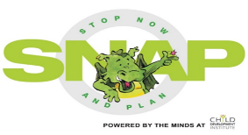

Fax
To: |  | From:
Fax: |  | Pages:
Phone: |  | Date:
Re: |  | CC:
Urgent For Review Please Comment Please Reply Please Recycle

Message:

