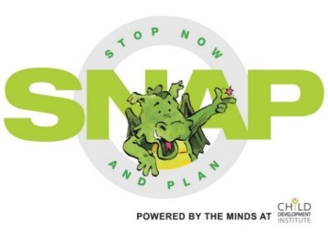
SNAP Volunteer and Facilitator Questionnaire
Do you have any ideas that might help us enhance/improve the SNAP experience…
for you?

for the boys?

for the parents?

for the siblings?

Anything else you would like us to know?

Thanks for being a part of SNAP!

