Meeting Minutes
CDS Family & Behavioral Health Services, Inc.

Meeting: INTERFACE CENTRAL
Date: April 9, 2015
Time: 4:00 PM
Location: 1400 NW 29TH ROAD
Date of Next Staff Meeting: April 23, 2015
Date of Next Training: May 14, 2015
PRESENT: L.ABNER,J.DUENAS,C.MCCRAY,D.GADDIS,S.GARRISON,A.GRAHAM,W.HARMON,C.JONAS,K.LEE,L.MANKER,C.MANSINGH,J.MATTOX,M.MCMANN,D.MCPHERSON,S.PARKER,B.SMITH,G.STRICKLAND,L.TAYLOR,N.THOMPSON,N.WALES,Z.WHITTER,W.WINTONS
ABSENT:A.JONES,R.MCDONALD,L.MOSLEY,V.ROSAS,S.STERLING,A.TENSLEY,V.WATSON
I. Business Operations:
A. Monthly Budget (Revenue and Expenses)
1. Sub-topic: Youth Care Worker Budget
Discussion: Agency wide we are making efforts to maintain scheduling to meet the budget guidelines
Outcome, Actions, Timeframe: All changes of schedules should be approved by a supervisor prior to the change.
B. Marketing and Business Development
1. Sub-topic:
Discussion: No discussion
Outcome, Actions, Timeframe:
C. Regulatory Issues
1. Sub-topic: Facebook, CDS
Discussion: Looking for a staff person(s) to assist
Outcome, Actions, Timeframe:
D. Human Resource Issues (Staffing and Training)
1. Sub-topic: Pending List
Discussion: ITEMS NEEDED
Self-Evaluation | Copy of current DL | Current Auto Ins. | Other
NONE | NONE | K. Lee  G. Strickland  A. Tensley  V. Watson  S. Garrison  A. Graham  L. Manker | Suicide Training Test:  M. McMann  V. Watson  Mental Health Training Test:  M. McMann  S. Parker  V. Watson | Transcripts:  L. Abner  W. Harmon  C. Mansingh
Outcome, Actions, Timeframe:
2. Sub-topic: TRAINING- FACE System, Achievement Process
Discussion: Giving px positives, negotiations for points, using the bank, accessing privileges (spending points), staying on Achievement.
Outcome, Actions, Timeframe: Staff should follow the FACE system and FULLY support Achievement px, Having px on Achievement level makes their success and the program success a goal that feels obtainable.
3. Sub-topic: David Easley: Parent Education and Guidance in Children
Discussion:
Outcome, Actions, Timeframe:

E. Annual Budget Planning and Process
1. Sub-topic:
Discussion: No discussion
Outcome, Actions, Timeframe:

II. Health and Safety: Program/Regional Coordinators
A. External Inspections
1. Sub-topic:
Discussion: No discussion
Outcome, Actions, Timeframe:
B. Self-Inspections (Reports, analysis, and recommendations)
1. Sub-topic:
Discussion: No discussion
Outcome, Actions, Timeframe:
C. Incident Reports (Reports, analysis of trends, recommendations)
1. Sub-topic:
Discussion: No discussion
Outcome, Actions, Timeframe:

III. Quality Improvement
A. File Audits and Case Record Review (reports and recommendations)
1. Sub-topic:
Discussion: No discussion
Outcome, Actions, Timeframe:
B. Outcome Management (status, reports, recommendations)
1. Sub-topic:
Discussion: No discussion
Outcome, Actions, Timeframe:
C. Accreditation and Regulatory Requirements
1. Sub-topic:
Discussion: No discussion
Outcome, Actions, Timeframe:
D. Policy and Procedure Updates and/or Review
1. Sub-topic:
Discussion: No discussion
Outcome, Actions, Timeframe:
E. Participant Complaint and Grievance (specific and quarterly review of trends)
1. Sub-topic:
Discussion: No discussion
Outcome, Actions, Timeframe:
F. Planning Documents (reports, status of goals and objectives, reformulation)
1. Sub-topic: Strategic Plan
Discussion: No discussion
Outcome, Actions, Timeframe:
2. Sub-topic: Accessibility Plan
Discussion: No discussion
Outcome, Actions, Timeframe:
3. Sub-topic: Cultural Competence Plan
Discussion: No discussion
Outcome, Actions, Timeframe:
4. Sub-topic: Input Plan
Discussion: No discussion
Outcome, Actions, Timeframe:
5. Sub-topic: Community Relations plan
Discussion: No discussion

Outcome, Actions, Timeframe:

IV. Risk Management
A. Risk Management Plan (exposure to loss)
1. Sub-topic:
Discussion: No discussion
Outcome, Actions, Timeframe:
B. Employee Concerns or Complaints
1. Sub-topic: Issues, Concerns, Questions
Discussion:
Outcome, Actions, Timeframe:

C. Potential regulatory audits and/or investigation of operations
1. Sub-topic:
Discussion: No discussion
Outcome, Actions, Timeframe:

V. Information Technology
A. Technology Plan
1. Sub-topic:
Discussion: No discussion
Outcome, Actions, Timeframe:

VI. Clinical/Program
A. Medical and Medication Issues
1. Sub-topic:
Discussion: No discussion
Outcome, Actions, Timeframe:
B. Counseling and Programming Issues
1. Sub-topic: Review/ Update- participant information
Discussion: Counselors provided information and overviews of participants.
Outcome, Actions, Timeframe: Staff are asked to respond accordingly.
2. Sub-topic: FACE System Review
Discussion: What adjustments would you make to the FACE system to; a. ensure staff are consistent in the implementation of the process, b. ensure px embrace and work the process, c. ensure success for all involved [participants, staff, program].
Outcome, Actions, Timeframe:
3. Sub-topic: Spotlight On Youth
Discussion: April 19, 2015 at
Outcome, Actions, Timeframe: Take px who have privileges and are not on assessment.
4. Sub-topic: Town Hall Meeting
Discussion: April 15, 2015, 6:00 PM GHS (doors open 5:30 pm) A meal will be served, door prizes.
Outcome, Actions, Timeframe: Youth with privileges and not on assessment should attend.
5. Sub-topic: Summer Program “Teen Lounge”
Discussion: June 15 – August 14, 2015 Monday-Friday 6-9pm @MLK
Outcome, Actions, Timeframe:
6. Sub-topic: FACE system update
Discussion: What changes would you suggest to improve the system?
Outcome, Actions, Timeframe:
7. Sub-topic: FYI Smart 911
Discussion: providing your home information to 911
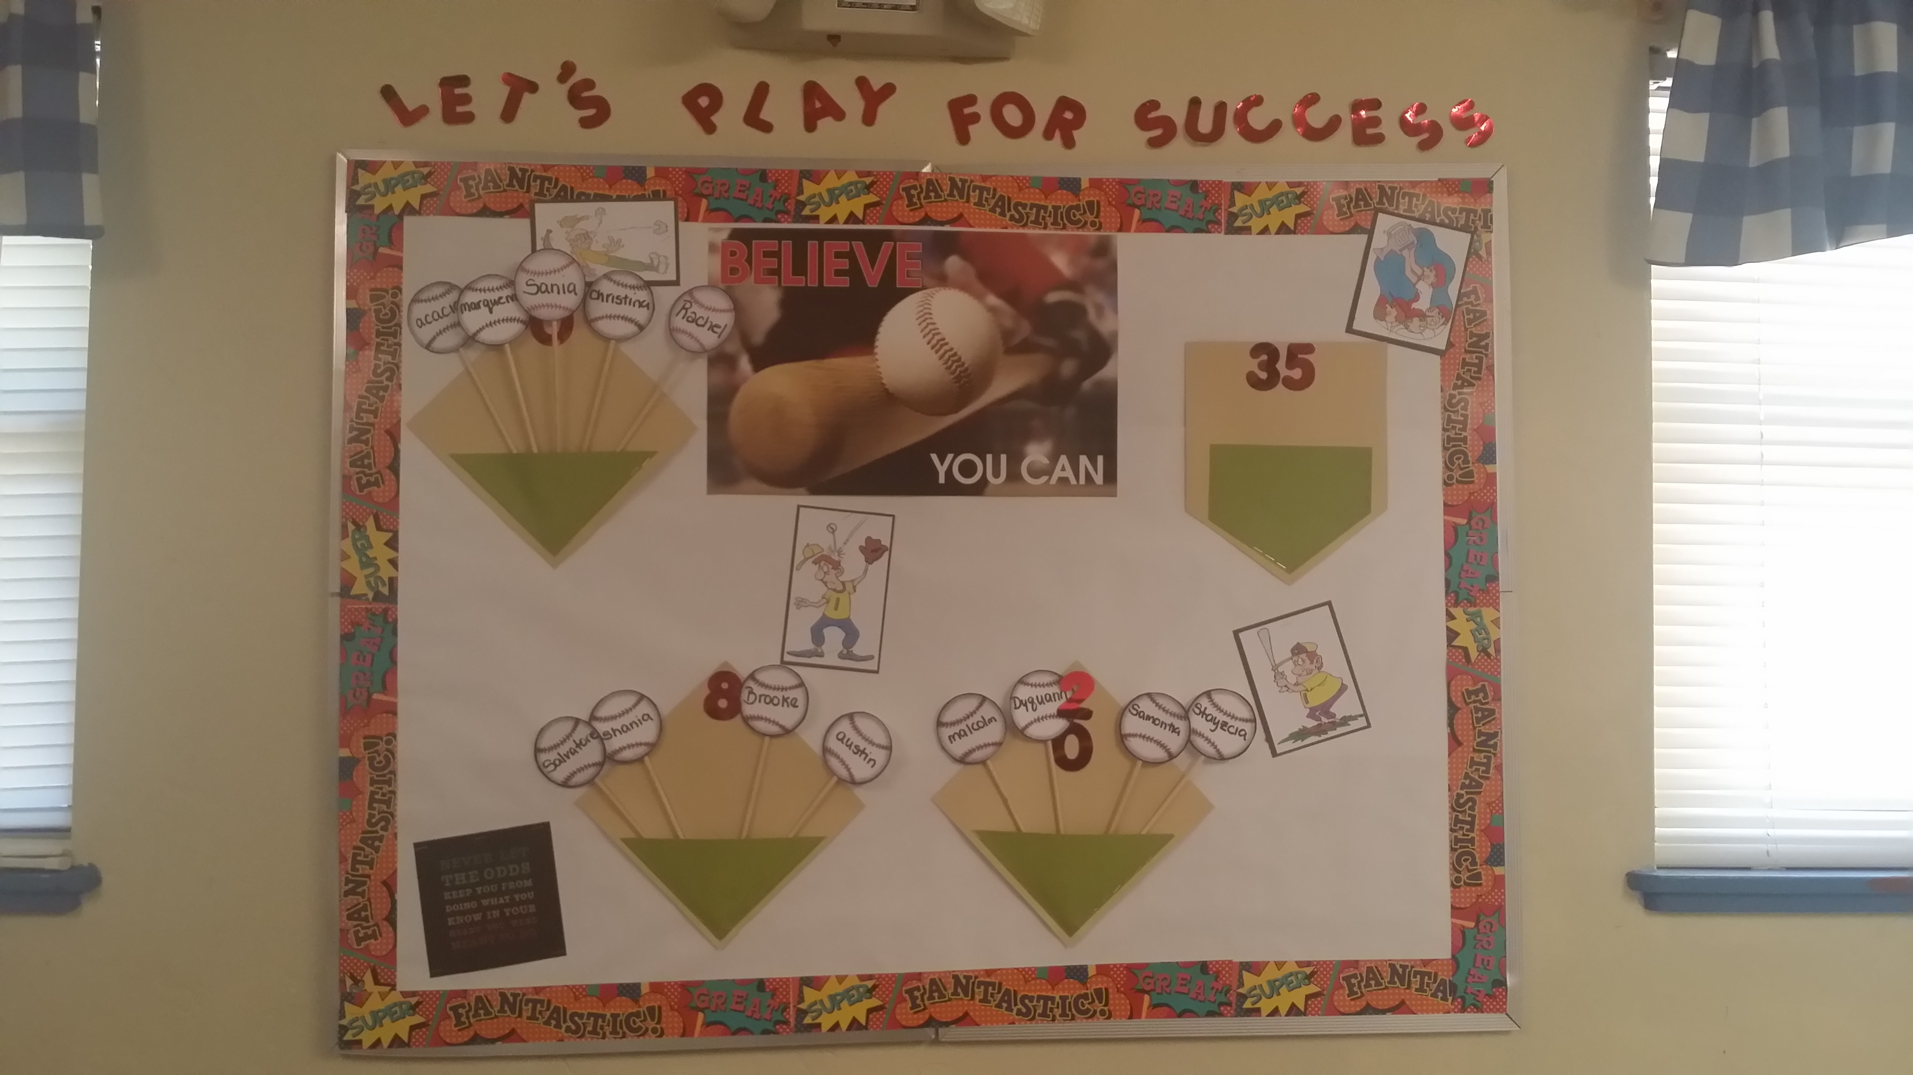
Outcome, Actions, Timeframe: www.smart911.com to register.
8. Sub-topic: Longevity Challenge Update
Discussion: Bulletin board in dining room will reflect the length of stay for Px using a baseball theme.
Outcome, Actions, Timeframe: Encourage px to make a “homerun” and stay at least 35 days.
9. Sub-topic: Cell Phones at the face (for staff)
Discussion: How does it affect the program/agency goal, work progress, supervision, and ability to have an effective team focus???
Outcome, Actions, Timeframe:

10. Sub-topic: Screenings with px in CSU from Baker Act
Discussion: Consult with a supervisor when we get screenings of youth who are in a Crisis Stabilization Unit for a Baker Act.
Outcome, Actions, Timeframe: We want to be sure to give guardians information
VII. Other Business:
1. Sub-topic: DROPS!
Discussion:
Outcome, Actions, Timeframe: Please continue to encourage your co-workers.
2. Sub-topic: SHOUTS OUTS
Discussion:
Outcome, Actions, Timeframe: Congratulations to the nominees from our last meeting.
Shout Out recipients for 4/9/15
Be sure to have Ms. Graham take your picture. Thank-you!

- Agency website: www.cdsfl.org
- Agency intranet website/ resource location: www.cdsgvl.org [call down list policy/by section/business sec./emg. plans/#15/a (policy# 1054)]
- IYPC Supervisors email-
  - Cassandra Evans-McCray: cassandra_evans@cdsfl.org, Zeke Whitter: zeke_whitter@cdsfl.org

Respectfully submitted by:

ALICIA HUTCHINSON |  | 04/11/2016
Name Date

INTERFACE: What do you do when…

A px is in need of medical services, we have called EMT. What information do we give EMT?

