Feelings Log
GLAD * MAD * SAD
I started feeling this way: at, on or in…

___ school ___ the dinning rm ___ outing
___group ___ living room ___w/ staff
___bedroom ___family session
___individual session ___outside
___the kitchen ___the bath rm ___other

Today, I feel ____ Glad
____Mad ____ Sad

If you can get mad, you can get GLAD!
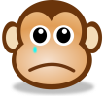
What
Happened?
- Someone teased me
- Someone stood up for me
- Someone did something I didn’t like
- Someone was nice to me
- Someone made me do something
- Someone took my stuff
- I did a good thing
- I did not do right
- Someone started a fight with me
- I ended a fight with someone
- Someone hurt my feelings
- Someone made me feel good
- It was just about the worst day in my life
- I had an AWESOME day

Who was that person, a…
- friend
- staff
- teacher
- volunteer
- family member
- enemy
- __________________

Someone

What did you do
talked it out ran away laughed
ignored it told a friend cried
Used anger control yelled
hit someone or something
told an adult walked away

WOW !
Right now it is
____ Morning ____ Afternoon
____ Evening/Night

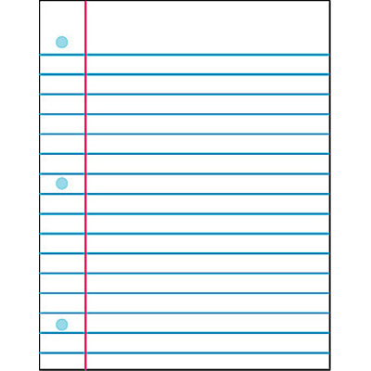
Is there anymore to tell

Thank You!
You are smart enough brave enough,
and strong enough

Name _______________________________________ Rev: 1/16 F-PR 1325

